**Laboratory Activity No. 1**

**Laboratory Activity No. 1:**

**Topic**: **Introduction to Software Design, History, and Overview**

**Title**: *Setting Up the Development Environment for Django Project*

**Results**: (print screen the result and provide the github link of your work)

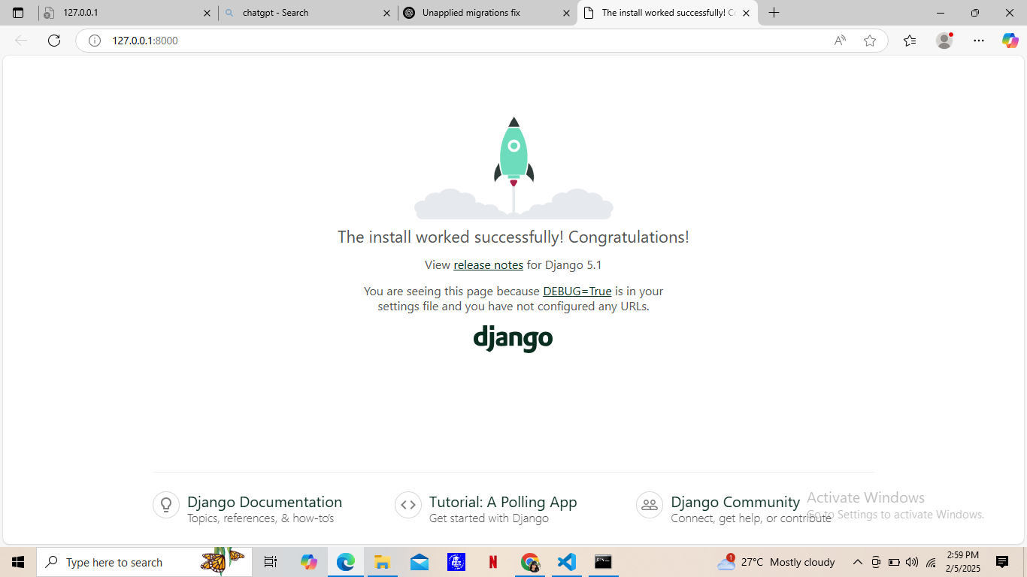

https://github.com/RYZZACADZ/ryzza_django

**Follow-Up Questions**:

1. What is the role of a virtual environment in Django development?

A virtual environment isolates project dependencies, ensuring that installed packages do not interfere with other projects or system-wide configurations. This makes development more manageable and avoids compatibility issues.

1. What are the advantages of using Django for web development over other frameworks?

* **Rapid Development:** Django’s built-in features allow developers to build applications quickly.
* **Security:** Includes protection against common security threats like SQL injection and CSRF.
* **Scalability:** Designed to handle high-traffic applications.
* **Built-in Admin Interface:** Reduces the need for writing backend administration tools.
* **Batteries-Included Philosophy:** Comes with authentication, ORM, and templating features by default.

**Findings**:

(Document any issues encountered and how they were resolved)

**Summary**:

* Installed Python and pip.
* Created a virtual environment and activated it.
* Installed Django and verified the installation.
* Created and ran a new Django project.
* Successfully launched the development server and viewed the Django welcome page.

**Conclusion**:

Setting up a Django environment is straightforward using Python’s virtual environments. Django’s ease of use and built-in features make it an excellent choice for web development. Ensuring proper installation and environment setup is crucial for a smooth development experience.